Current Market View – July 2026

Investment Markets
Global Markets
Equities spent July moving sideways, but the calm surface hid sharp rotations beneath. The US–Iran war stalemate kept fuel prices elevated, feeding inflation prints and weighing on consumer-facing sectors. At the same time, AI companies, previously the engine of global equity leadership, showed signs of weakness as investors questioned the sustainability of hyperscaler capex and reacted to increasingly circular financing structures around chip purchases. This triggered a rotation out of high-multiple tech and into value-heavy markets such as the UK and parts of Europe, where energy, mining, and banks outperformed. For asset allocators, July was a month of trimming AI-exposed cyclicals, maintaining defensives, and favouring markets with commodity leverage or stable cash-flow sectors.
Bonds spent July repricing the entire macro narrative as investors reassessed the path of inflation and interest rates. The appointment of Kevin Warsh as the new Fed Chair introduced uncertainty about how firmly the central bank would anchor inflation expectations, and markets responded by pushing yields higher across key maturities. This shift tightened financial conditions and reinforced the idea that the “higher-for-longer” rate environment was not yet behind us. For allocators, July was a month defined by caution: maintaining balanced duration, reducing exposure to rate-sensitive credit, and favouring high-quality sovereigns as the bond market re-established itself as the primary barometer of macro credibility.
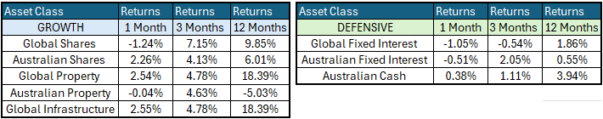
Global Share Markets
Global share markets were essentially flat through July, marking a pause after the rebound that followed the brief dip at the start of the US–Iran war. The stall reflected three broad pressures weighing on sentiment. The first was the stalemate in the conflict itself, which kept fuel prices elevated and pushed through into headline inflation, consumer confidence, and spending. The second was the tone of the US Federal Reserve under its new Chair, Kevin Warsh, whose softer stance on inflation raised fears that price pressures would remain higher for longer. That shift fed directly into higher bond yields, a combination that is rarely supportive for equities.
The final reason was a widening concern that the AI boom may be starting to deflate, driven by four developments that unsettled markets during July. Investors worried that China was rapidly closing the gap with the US in AI capabilities, as highlighted by Moonshot’s launch of the Kimi K3 model during the month and the blockbuster IPO of memory chip maker CXMT. Nvidia added to unease with another circular financing arrangement, this time guaranteeing SoftBank/OpenAI debt used to purchase more Nvidia chips. At the same time, hyperscalers were burning through operating cash flow and taking on substantial debt to fund massive AI capex programs, despite the absence of compelling commercial use-cases beyond frenzied FOMO spending. There were even rising fears that the AI capex boom itself was becoming inflationary, increasing the risk of further rate hikes that would pressure private credit, private equity, venture funds, hedge funds, and the banks that finance them.
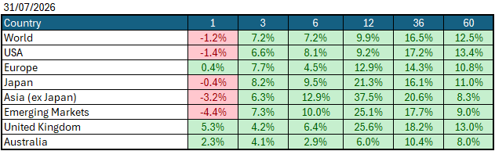
Data Source: AFM as of July 31, 2026.

Global Bond Markets
July was a weaker month for global bonds, with yields rising across the board as the war in Iran continues to drag on in the Middle East, thereby reinstating inflation worries globally. On top of this, the new Federal Reserve Chairman Walsh removed medium-term guidance from the bank, creating more uncertainty in global markets and further boosting bond yields. Europe was the worst-performing geography, with Italy's bond yields increasing by +0.43%, France increasing by +0.35%, and Spain increasing by +0.31%
Interest rate markets were higher in July, with the US 10-year Government bond rate increasing to 4.736% and the UK 10-year Gilts increasing to 5.311% from 4.949% in June 2026.
Domestic Bond Markets
Treasury yields increased across all maturities in Australia as market worries about inflation returning due to higher oil prices from developments in the Middle East resurfaced. The Australian 10-year treasury bond increased by +0.23% to 4.935%. Whilst the latest inflation print saw inflation decrease to 3.8% from 4.0% in June, Australian bonds began to price in food inflation and higher trucking costs later in the year due to higher energy prices.
Investment Climate
U.S. equities posted a down month for July 2026 as investors stepped back from the aggressive positioning that dominated early-year trading and shifted toward balance-sheet strength, cash-flow visibility, and defensiveness. This was driven primarily by more questions about expected returns on AI-related capital investment and more hawkish sentiment from the US Federal Reserve following a higher inflation print during the month. The US earnings season began in July and showed that the underlying economy is operating well, but also revealed some weakness for businesses outside the AI hyperscaler industries.
Over the medium term, investors are encouraged by the anticipated productivity benefits from AI and the hyperscalers' investments in AI. However, with the unsettled nature of the bond markets due to the war in Iran, the short term has put the handbrake on the level of encouragement. If the US changes its tone and begins raising interest rates under its new Federal Chairman, Kevin Warsh, the medium term could become much less encouraging.
Long-term investors are cautiously optimistic about a recovery period ahead. Global central banks continue to signal their resolve to bring inflation under control; however, economic data show signs of stabilisation despite elevated inflation, which could prompt central banks to raise interest rates in 2026.
The following commentary is based on month-end closing prices as of July 31, 2026:
Global share markets were mostly weaker in June, except in Australia and Europe, where these markets have less exposure to global technology players. Investors are unsure whether geopolitical events in the Middle East will end soon, with oil rising substantially over the month, reviving fears that inflation will not subside in the near term. The AUD/USD gained following changes in US interest rate expectations from 0.692 to 0.7022 (+1.5%).
The U.S. Fed held the federal funds rate target range at 3.50%-3.75% when it met on the 28th/29th June 2026. Last month, the rhetoric of a soft landing came under pressure amid the expected rise in inflation following the oil price spike's impact on food prices, bringing the chances of a rate hike in the US back into focus. The next Fed meeting is on the 15th/16th September 2026.
The underlying short-term theme is "mildly cautious" for shares.
The situation in the Russia/Ukraine conflict remains unchanged, with the latest conflict between Israel and Gaza (Hamas) remaining unchanged as well. Volatility and risk increased as the USA/Israel moved towards a war with Iran.
Investor Focus
For Australia, investors focused on the following issues:
- Cost of living expenses and the impact on consumer spending.
- Commodity prices (post-China policy changes) and the impact on company profits.
- The level of interest rates and the delicate position of the RBA, given the global volatility in markets.
- Rising Oil Prices as conflicts with Iran re-escalates
- U.S. tariffs and the impact on Australia's exports (if any).
- Inflation (year-over-year) decreased to 3.8% in the June quarter, with the next quarterly CPI being released on October 28, 2026.
- Government spending and the rising debt level.
Currency
The Australian Dollar closed stronger, with AUD/USD at 0.702 at the end of July 2026, up from 0.692 in June. As the Aussie dollar is a 'risk currency', it always sells off during global crises, as we saw in March, regardless of local conditions. July marked the second month of a new Federal Reserve governor, with Walsh removing medium-term interest rate guidance from the Federal Reserve, adding more uncertainty to interest rate markets about whether the Fed is willing to raise rates to fight inflation or keep them on hold with inflation above the target band.
Currency forecasters see the AUD/USD range between:
0.65 and 0.75 cents in the medium term and most likely to trade within the:
0.5500 to 0.7500 range in the longer term.

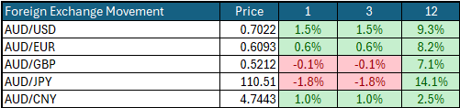

Australian Economy
Australia's latest GDP data for the first quarter of 2026 showed an annual growth rate of 2.5%, marginally down from 2.6% in the final quarter of 2025. Unemployment held steady in June at 4.4%, in line with 4.4% in May 2026. The year-over-year (Y-O-Y) inflation rate decreased to 3.8%, down from 4.0% in June 2026, but remains outside the Reserve Bank's targeted 2% to 3% inflation range and still could prompt another rate hike later this year.
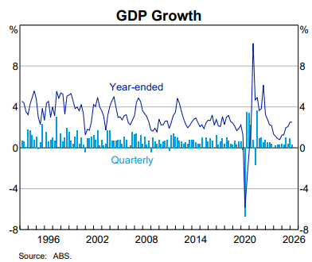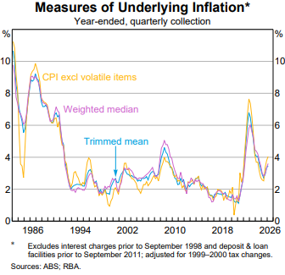

Current Market View

Domestic View
The overall investment view for shares is "cautious" over the short term, "cautiously optimistic" over the medium term, and "long run" as corporate profits continue to grow faster than inflation and as the need to build out data centres drives commodity prices higher.
The market is currently pricing in a small chance of an interest rate hike on the 10th/11th of August 2026, due to a "softer" inflation print in July that showed inflation is still outside the RBA's target range of 2-3% but has begun trending back down towards the target band.

Global View
The global share market remains cautious, with concerns around AI profitability weighing on AI companies over the month, alongside the looming threat of a global inflation spike that could force many economies to raise interest rates. Given the current tensions in the Middle East, we could see a global slowdown in GDP growth, as energy production cannot keep pace with the rollout of AI data centres.
Where to From Here
- Continued shift from rules-based order and win-win multilateral trade to power-based order and win-lose trade deals. Trump did not start this. The shift started in the 2010s with the U.S./Europe letting Putin take Crimea in return for cheap gas for Germany/Europe, and the U.S./Japan letting China militarise the South China Sea. It has certainly accelerated under Trump. Lower cross-border trade & investment, more reliance on government subsidies & distortions, and inflationary onshoring of uneconomic industries.
- Sticky inflation - political pressure on central banks to keep rates low – populist pressure on governments to keep deficit spending. Tariffs + onshoring are adding to costs/prices. Bond yields to stay elevated or even drift higher, risk of bond yield spikes, or a sudden need for rate hikes, unsettling / breaking share markets.
- Share markets continue to be supported by good profit growth for now. Shares everywhere are expensive, buoyed by loose monetary & fiscal policies and a near-certainty that governments will throw 'free'/borrowed money at any problem.
- Commodities rally gathering pace, rising demand soaking up oversupply, AI/data centre boom (industrial metals, energy, water, land), global rearmament, especially Europe, Japan, Canada. This should support the ASX market, as long as banks avoid a local recession.

Footnote
This market update is written by Atlas Funds Management Pty Ltd for and on behalf of HNW Planning on 14 August 2026. Atlas Funds Management is an external asset consultant and consults to the HNW Investment Committee. Atlas Funds Management does not provide any general advice or personal advice regarding any potential investment in any financial products within the meaning of section 766B of the Corporations Act. No consideration has been made of any specific person's investment objectives, financial situation or needs. The provision of this presentation is not and should not be considered as a recommendation in relation to an investment in any entity or that an investment in any entity is a suitable investment for any specific person. Recipients should make their own enquiries and evaluations they consider appropriate to determine the suitability of any investment (including their investment objectives, financial situation, and particular needs) and should seek all necessary financial, legal, tax and investment advice. Atlas Funds Management Pty Ltd, it's directors and employees do not accept any liability for the results of any actions taken or not taken on the basis of information in this presentation, or for any negligent misstatements, errors or omissions. This presentation is not an advertisement and is not intended for public use or distribution. Past performance of a fund is no guarantee of its future performance.

